**Vlookup Lab**

1. Use VLOOKUP to find the product names for each ProductID in the Orders worksheet.

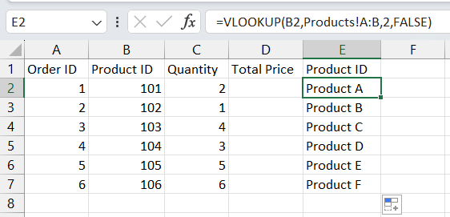

1. Use VLOOKUP to find the price for each ProductID in the Orders worksheet, then calculate the TotalPrice by multiplying the Quantity by the Product Price.

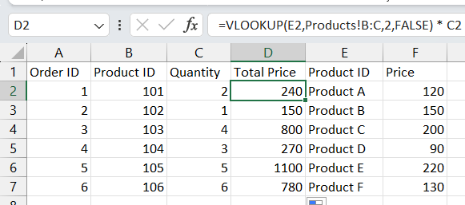

1. Use VLOOKUP to check if there are any ProductIDs in the Orders worksheet that do not exist in the Products worksheet.

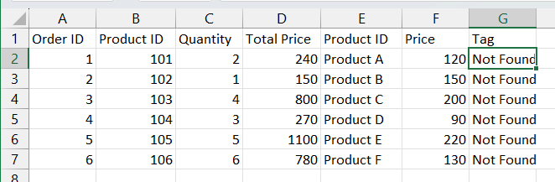

1. Assume a discount of 10% is given on all products. Use VLOOKUP to find the original price and then calculate the discounted price.

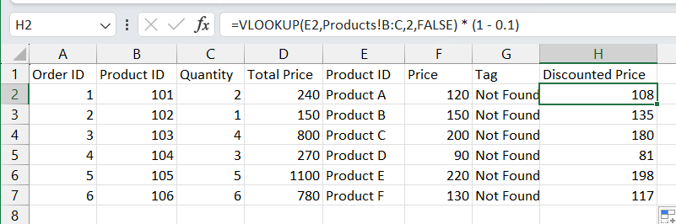

1. Use VLOOKUP to find the price for each ProductID and then calculate the order value. Find the maximum order value from the list.

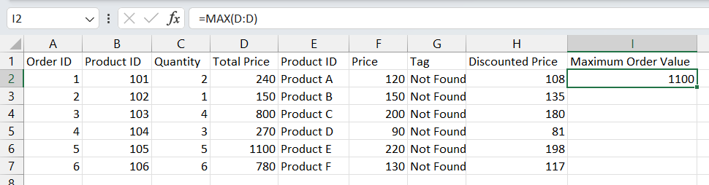

1. Use VLOOKUP to find out which products from the Products worksheet have not been ordered.

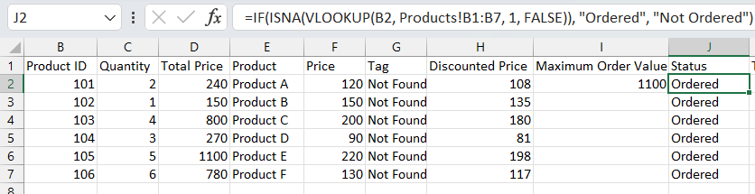

1. Use VLOOKUP to find the Product name and summarize the total quantity sold for each product.

